VA Home Loan Program Offers Advantageous Path to Home Ownership
One of the great benefits of serving in the U.S. military is the Veterans Affairs Guaranteed Home Loan program. Since it was established in 1944, the VA Home Loan program has provided more than 24 million veterans with an affordable path to home ownership.
Yet, according to a 2022 Freddie Mac survey, 64% of active-duty service members expect that finding an affordable place to live after leaving the service will be extremely or somewhat challenging.
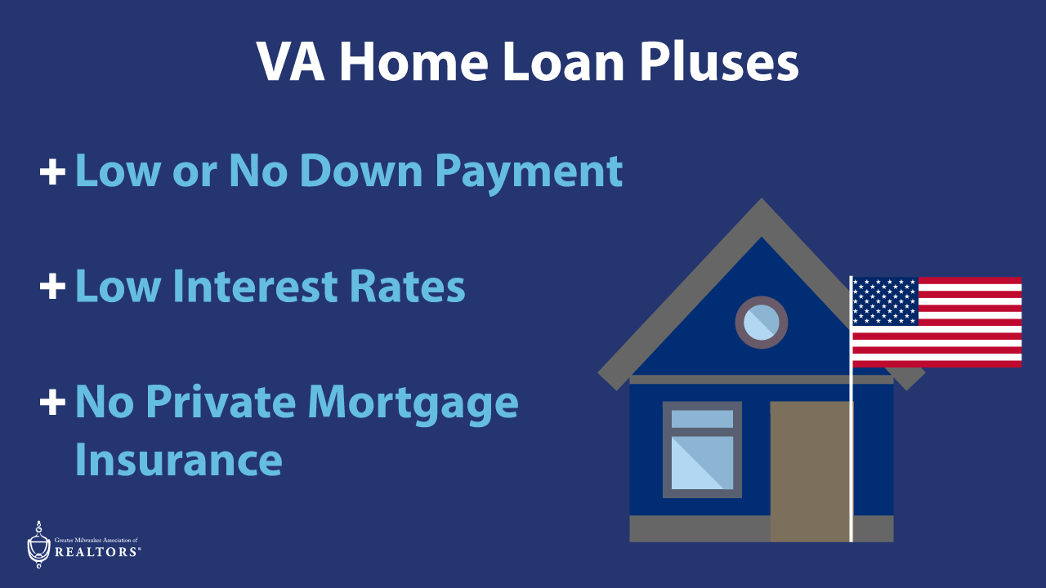

“The inability to come up with a down payment and limited personal savings often present the biggest hurdles for both active duty and those leaving service,” says Angela Walters, board chair for the Greater Milwaukee Association of REALTORS® (GMAR). “However, since the VA home loan program allows for small or zero down payments, no private mortgage insurance (PMI), and low interest rates, these factors aren’t obstacles at all.”
VA Home Loans Offer Many Benefits
In addition to low interest rates, no downpayment, and no PMI, other advantages of the loan program are equally desirable.
For example, unlike other types of loans which have a debt-to-income ratio, the VA home loan does not because it’s backed by the U.S. Department of Veterans Affairs. For active-duty service members who are relocating to a new active-duty assignment, the process can be expedited and completed in just two to three weeks. And there’s also no cap on how many times the loan program can be used.
According to Theresa Dixon, principal real estate advisor with The Wisconsin Real Estate Group, the loan program is a great way for vets to build wealth.
“A veteran can purchase a multi-family property, live in one of the units and rent the other,” says Dixon. “There’s only a six-month requirement for how long they must reside at the property. That means, the program could be used again to purchase another property while using the multi-family as a real estate investment that provides ongoing income.”
Dixon also notes that the VA Home Loan program has significant tax benefits for veterans residing in Wisconsin.

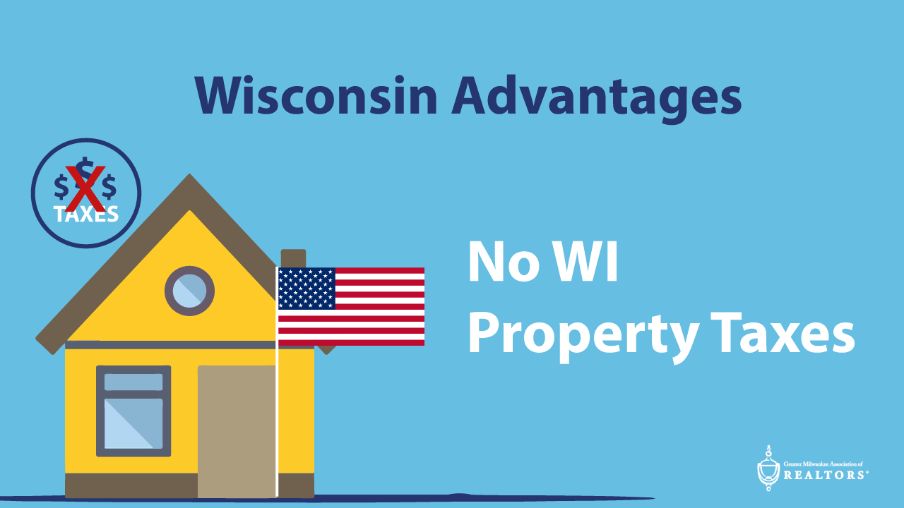
“Vets who meet the 100% disability requirements don’t have to pay property taxes in Wisconsin,” she explains. “Retired vets also don’t have to pay property taxes in Wisconsin, making it a great place to retire.”
Who Qualifies?
Eligibility requirements for the VA Home Loan program fall into several categories:
- Active-duty personnel with at least 90 days of service during wartime or 181 days during peacetime
- National Guard or Reserve members with six or more years of service
- Non-active personnel with at least two years of prior service
- Retired military personnel
- Surviving spouses
The Program Works Better with an MRP
Establishing eligibility is the first step to getting a VA Home Loan. A certified Military Relocation Professional, also known as a MRP, can help with obtaining the loan program’s required Certificate of Eligibility. A real estate professional with the MRP certification has specialized experience working with current and former military service members to recognize eligibility opportunities.

REALTORS with an MRP certification apply knowledge of the military relocation process to guide service members through the real estate transaction, explain the basics of VA financing, and find housing solutions that take full advantage of the home loan program.

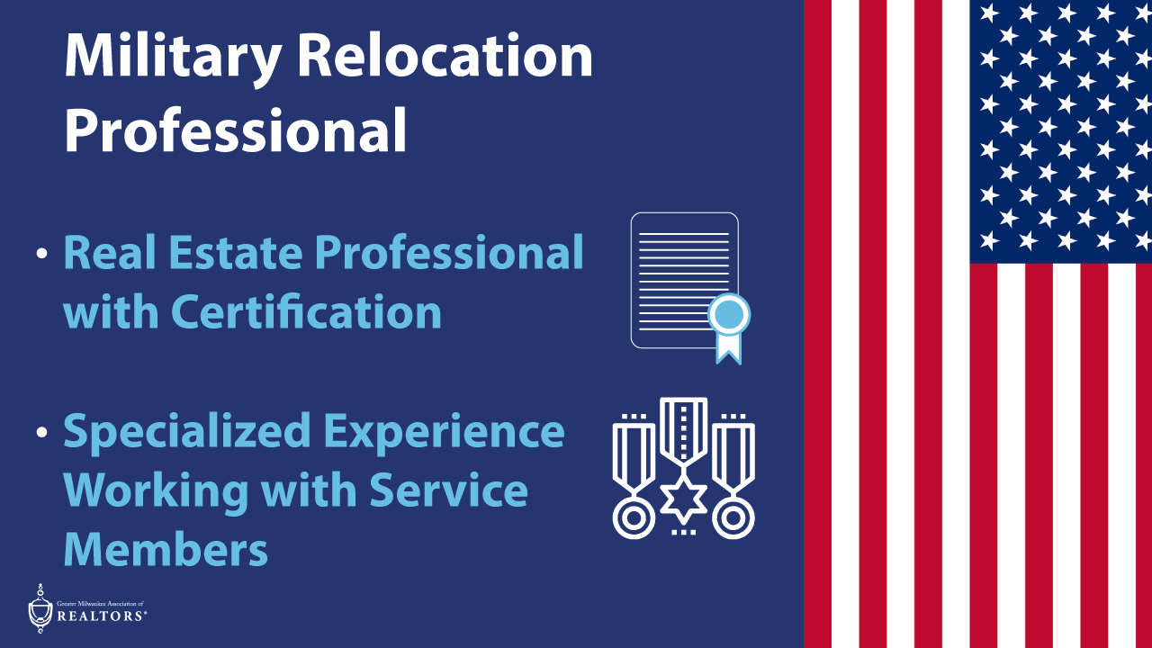

“When military staff and their families relocate, the services of a MRP who understands their needs and timetables makes the transaction easier, faster, and less stressful,” says Scott Bush, vice president of operations for GMAR. “MRPs have taken a class and are certified in understanding the processes and procedures involved in a military relocation and how these impact service members’ relocation and housing choices.”
MRP’s can even coordinate remote transactions, such as moving from out of state to the greater Milwaukee area. They can also recommend local lenders who understand the VA loan program and have a strong pulse on the local real estate market.

Working with an MRP and local lender can help veterans obtain the home of their dreams while enjoying the many other advantages of the VA home buying program.
The REALTOR® Advantage
A REALTOR is a member of the National Association of REALTORS, is committed to a Code of Ethics, and has the expertise to find the right home for everyone. Look for the “R” to determine if your agent is a REALTOR.
Locally, the Greater Milwaukee Association of REALTORS is a 5,500-member strong professional organization dedicated to providing information, services, and products to help Realtors help their clients buy and sell real estate. Visit gmar.com for more information.

